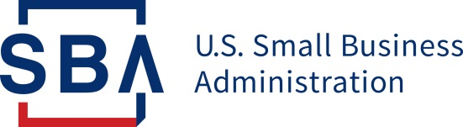

PRESS OFFICE

Release Date: May 21, 2020 Contact: lola.kress@sba.gov
Release Number: 20-20 Follow us on Twitter, Facebook, Blogs & Instagram

SBA Regional Administrator Ashley D. Bell & Rapper, Entrepreneur

Tip "T.I." Harris Reached over 100,000 Entrepreneurs

Across the South

Goal was met in reaching 100k minority entrepreneurs to discuss COVID-19 Recovery opportunities

ATLANTA – Yesterday evening, May 20th at 6:00 p.m. ET, Ashley D. Bell, SBA Regional Administrator and Entrepreneurship Policy Advisor for the White House Opportunity & Revitalization Council and Tip “T.I.” Harris, rapper, entertainer, and entrepreneur hosted a successful call for entrepreneurs across the South. The call addressed opportunities for recovery for historically distressed communities which have been disproportionately impacted by COVID-19. They successfully reached over 109,000 callers last night and had a reach of millions via social media outlets.
Tip “T.I.” Harris says, “This call was important to do because I believe it’s critical for us to be informed and get better educated on what we can do, how to do it and where to go to get it done, especially during times of crisis. I simply did what I do best and that is connect the people with the information.”
The audience on the call received a great deal of information including hearing from local and state elected officials representing their constituents, lenders and experts in the financial fields including Eddie George, Wealth Management Specialist and retired NFL player. John Hope Bryant, Founder & CEO of Operation Hope moderated a conversation with chamber leaders, church leadership and non-profits to discuss the importance of these pillars on our communities and the importance of access to recovery capital for them. Entrepreneurs and small business counselors talked about their tickets to success.
“50% of black business owners have 0-10 days of working capital, but do not have access to traditional banking facilities. Without this critical link to funding and opportunities and amidst the COVID-19 crisis, an entire generation of minority entrepreneurs could be lost,” says Ashley D. Bell, SBA Regional Administrator. “Our goal with 100,000 Strong is to organically reach entrepreneurs throughout the underserved communities of the South by working with the great support of speakers we had on this call.”

Please coordinate media interviews and for a complete list of speakers, please contact Lola Kress, SBA Regional Communications Director, (404) 330-4737 or lola.kress@sba.gov@sba.gov

###

About the U.S. Small Business Administration
The U.S. Small Business Administration makes the American dream of business ownership a reality. As the only go-to resource and voice for small businesses backed by the strength of the federal government, the SBA empowers entrepreneurs and small business owners with the resources and support they need to start, grow or expand their businesses, or recover from a declared disaster. It delivers services through an extensive network of SBA field offices and partnerships with public and private organizations. To learn more, visit www.sba.gov.

