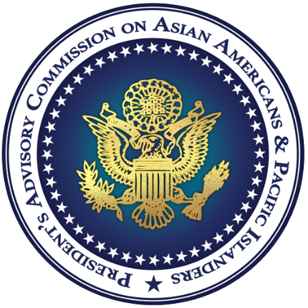

FOR IMMEDIATE RELEASE
Friday, June 12, 2020
CONTACT: whiaapi@doc.gov

President’s Advisory Commission on Asian Americans and Pacific Islanders (PAC-AAPI) Hosts June AAPI Business Town Hall

WASHINGTON, D.C. – On June 11th, the President’s Advisory Commission on Asian Americans and Pacific Islanders hosted their second virtual AAPI Business Town Hall. Chair of the Commission, Dr. Paul Hsu of Florida, provided opening remarks, in which he highlighted the many accomplishments of Asian American and Pacific Islanders. He also emphasized the five areas that both the Commission and the White House Initiative on Asian Americans and Pacific Islanders are focused on: The Impact of Covid-19 on AAPI Small Businesses, Passing the Torch, Breaking the Glass Ceiling, Bridging the Income Gap, and AAPI Women in Leadership.

“Under President Trump’s economic leadership and pro-growth policies,” said Dr. Hsu, “AAPI-owned businesses have an opportunity to thrive, just as the mighty rising water lifts all boats!”

Commissioner George Leing of Colorado moderated this listening session, which was hosted by the White House Initiative on Asian Americans and Pacific Islanders (WHIAAPI). Nearly 200 AAPI business and community leaders participated along with most of the fourteen Commissioners. Speakers included Congresswoman Amata Radewagen of American Samoa, Mr. Alex Flemister, Associate Director of the Office of Public Liaison at The White House, as well as brief introductions by the Executive Director of WHIAAPI, Mrs. Tina Wei Smith.

These public forums are a platform for federal officials to highlight resources and opportunities for the AAPI community. The Associate Administrator of the U.S. Small Business Administration (SBA), Mr. Larry Stubblefield, provided a presentation on the SBA Contracting Assistance Program as well as disaster relief funds related to COVID-19 and recovery information. The International Trade Administration (ITA) shared resources on how businesses can grow their exporting opportunities and highlighted the ways the U.S. Commercial Service can assist businesses with competing and winning in the global marketplace. Lastly, we heard from the U.S. Department of Agriculture’s Rural Business-Cooperative Service on the Business and Industry (B&I) Loan Program as well as the B&I Guaranteed Loan CARES Act Program.

As the Commission prepares their advisory reports to the President, these town halls and listening sessions reflect the mission and importance of the Asian American and Pacific Islander community to our country. Those who shared their concerns to the Commission represented several different states, while the audience participants hailed from 34 different states, including the District of Columbia. Many of the speakers provided insight on how the COVID-19 (coronavirus) outbreak has affected AAPI-owned businesses across the country. There were also concerns about access to federal resources, international trade, competing for higher education, and anti-AAPI sentiments. In response to concerns about harassment of AAPIs due to the virus, the White House Initiative on Asian Americans and Pacific Islanders’ interagency working group is coordinating with the U.S. Department of Justice Community Relations Service (CRS) to ensure active engagement with local communities on addressing these issues.

The slide deck from each of the presenters along with the program agenda can be found at: https://www.mbda.gov/form/pac-aapi.

###

Advancing the economic empowerment of Asian Americans and Pacific Islanders

About WHIAAPI & PAC-AAPI: Established by President Trump, the White House Initiative on Asian Americans and Pacific Islanders (WHIAAPI) and the President’s Advisory Commission on AAPIs (PAC-AAPI) work to broaden access by Asian Americans and Pacific Islanders (AAPI) employers and communities to economic resources and opportunities, thus empowering AAPIs to improve the quality of their lives, raise the standard of living for their families and communities, and more fully participate in our economy. The President’s Advisory Commission on Asian Americans and Pacific Islanders (PAC-AAPI) is established pursuant to Executive Order 13872 (May 13, 2019) to advise the President, through the Secretary of Commerce and the Secretary of Transportation. The PAC-AAPI and the WHIAAPI Office is located in the US. Department of Commerce, and the Minority Business Development Agency provides financial and administrative support for the performance of the Commission’s functions.

